NEW MEMBERS - PLEASE COMPLETE BOTH SIDES OF THIS FORM

Coomba Connections subscriptions and Progress Association membership

1 July 2019– 30 June 2020

Membership Options
Please mark to indicate your choice
For those wanting a PRINT COPY of Coomba Connections: |  |  | Your selection
Single Membership with Coomba Connections Print Copy,  delivered in local area. |  | $20.00
Single Membership with Coomba Connections Print Copy,  posted outside local area. |  | $32.00
Family Membership with Coomba Connections Print Copy,  delivered in local area. |  | $24.00
Family Membership with Coomba Connections Print Copy,  posted outside local area. |  | $36.00
For those wanting EMAIL ONLY COPY of Coomba Connections:
Single Membership with Coomba Connections Email Copy | $10.00
Family Membership with Coomba Connections Email Copy | $14.00

If you chose to receive a printed copy to be posted outside local area, an
ADDITIONAL $12 has been included in above prices to cover postage costs.
(Local delivery area is the area from the Coomba Rd. & Lakesway intersection to Coomba Village.)

DATE …………………. AMOUNT PAID:$.......................... by cash// cheque online (tick or circle)

PLEASE COMPLETE AND RETURN THIS FORM To either
Del Jeal 47 Coomba Rd., Coomba Park 02 6554 2001 – deljeal@nepeanblue.com.au
Or Coomba Shop with correct payment in an envelope - cash/cheque
OR pay Direct Bank Deposit online,
Account Name: Coomba & District Progress Association Inc.
BSB: 032 543. Account No: 113606
Please use your surname as the bank reference

Your Name: ………………………………………………………………………………………………………………………
Your Phone Number: ………………………………………………………………………………………………………………

Email address: ………………………………………………………………………………………………………………………………

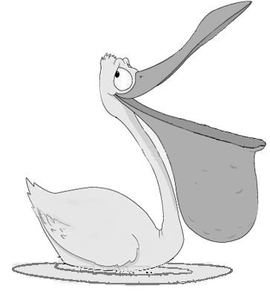
COOMBA & DISTRICT PROGRESS ASSOCIATION INC.
(established 1974)

President: David Gemmel 1601 Coomba Rd Coomba Bay 2428 6554 2269
Vice Pres: Barbara Filter 6 Dandenong Cresc Coomba Park 2428 6554 2312
Secretary: Del Jeal 47 Coomba Rd., Coomba Park 2428 6554 2315
Treasurer: Beverly Fitzpatrick 18 The Lakelands Coomba Park 2428 65542146

Dear Members

In 2014 Coomba & District Progress Association Inc. amended its Constitution to bring it in line with rements of NSW Fair Trading. This form asks for the details that are required on an application for Membership.

Applicants for new Memberships or for re-activation of a previous membership that has not been renewed in the past 12 months are asked to complete pages 1 and 2 of this form.

Members who are making an ongoing renewal need only fill in the other page of this form.

Please complete the form and submit it with payment to the Treasurer or Secretary.

Thanks,

Del Jeal

Application for membership

COOMBA & DISTRICT PROGRESS ASSOCIATION
(Incorporated under the Associations Incorporation Act 2009)

I/we, …………………………………………………………………………………………………………………………….
[full name of applicant]

of ………………………………………………………………………………………………………………………………….
[home address]

………………………………………………………………………………………………………………………………………
[occupation]
hereby apply to become a member/s / re-activate a lapsed membership

(cross out which does not apply)
of the above named incorporated association. As a member, I agree to be bound by the constitution of the association for the time being in force.

……………………………………………………………………………………………………………………………………
(Property address in Coomba area if different from home address)

……………………………………………………………………………………………………………………………………..
(e-mail address)

Home Phone: ………………….................. Mob Phone ……………………………………………………………..

Date: …………………………………Signature of applicant: ………………………………………………………………………

Please return this form to the
*Association Treasurer, - coombaprogress@gmail.com OR
*Association Secretary, 47 Coomba Rd., Coomba Park - deljeal@nepeanblue.com.au
*Or the village shop, 8 Kirribilli Rd., Coomba Park.
together with the appropriate fee (in an envelope or similar if cash or cheque),
which also covers your Coomba Connections subscription.
NOTE. The schedule of fees is shown on page 1, with bank details for electronic banking.

